# Keyboard shortcuts activity

The Microsoft Office 365 article, *Keyboard shortcuts in Word*, has the full documentation for [Windows](https://support.office.com/en-us/article/keyboard-shortcuts-in-word-95ef89dd-7142-4b50-afb2-f762f663ceb2#bkmk_frequentlyusedshortcutsmac&PickTab=Windows) and [macOS](https://support.office.com/en-us/article/keyboard-shortcuts-in-word-95ef89dd-7142-4b50-afb2-f762f663ceb2#bkmk_frequentlyusedshortcutsmac&PickTab=macOS) and others. In all versions, it starts by saying,

*Many users find that using keyboard shortcuts for Word helps them work more efficiently. For users with mobility or vision disabilities, keyboard shortcuts can be easier than using the touchscreen, and are an essential alternative to using a mouse.*

|  |  |
| --- | --- |
| https://upload.wikimedia.org/wikipedia/commons/thumb/f/fa/Apple_logo_black.svg/800px-Apple_logo_black.svg.png | If you are running Windows on an Apple Mac laptop, this activity may be a challenge because it assumes using a Microsoft standard keyboard. See [Apple Keyboard in Windows with Boot Camp](https://support.apple.com/en-us/HT202676) and [Keyboard mappings using a PC keyboard on a Macintosh](https://support.microsoft.com/en-ca/help/970299/keyboard-mappings-using-a-pc-keyboard-on-a-macintosh). Mac people may find word processing more comfortable in the native macOS although that will not help learn the keyboard shortcuts in the Visual Studio IDE which runs only under Windows. |

To Enable Editing of a downloaded Office file, **Alt-F** for the File menu, **TAB**, **TAB**, **Enter**.

To have Windows always show keyboard shortcuts (off by default), press the Windows key, begin typing "underline access key…" until "underline access key shortcuts in menus when available" appears; press Enter. Under "Change how keyboard shortcuts work", turn on the switch for "Underline access keys when available".

To move or resize a window when one or more edges cannot be reached with a mouse, press Alt + spacebar. A menu will appear, select an option. Use the arrow keys to move a window. To resize, first use arrow key(s) to indicate the edge or corner, then any arrow key to adjust the size. Enter makes the change, Esc cancels.

Change the View of a document to Web Layout for on-screen review: **Alt+W L1**

Create *one* new blank Word document for *all* your activity answers. ( **Ctrl+N** )

As you go through this document, practice your keyboard shortcuts by selecting, copying, and pasting the paragraphs starting with 🡺 (and related text with answer box) to your new document and add your answers.

*ALT+TAB will be very handy switching between this document and your new activity answer document.*

🡺 Your name: Student No.: UserID: @mySeneca.ca

**Position the mouse pointer at the end of this line ==>**

**Time yourself starting from the moment you start moving the mouse to…**

*Highlight and copy this line of text using only your mouse and paste it below this line* ***TWICE****.*

🡺 How many seconds did it take to copy and paste using the mouse?

🡺 What were the steps including all hand movements?   
 (if too difficult to explain, explain why it is difficult)

Steps to do the same using a keyboard (after positioning cursor as noted below):

* Down arrow twice.
* Home key – positions cursor at beginning of line of text
* Shift + Ctrl + Down arrow – selects a paragraph of text
* Ctrl+C, Ctrl+V, Ctrl+V *or* Ctrl+C, Down arrow, Ctrl+V – copy & paste

**Position the cursor at the end of this line (use the Arrows and End key) ==>**

**Time yourself starting from the moment you start keying to…**

*Highlight and copy this line of text using only your keyboard and paste it below this line* ***TWICE****.*

Practice the key sequence a few times.

🡺 After practicing, how many seconds did it take to copy / paste using the keyboard?

Most people, once they become accustomed to keyboard navigation, get very quick at it (especially programmers). Few people (even programmers) are much faster using a mouse now than they were the first time they used a mouse. But if you must use a mouse, get used to using it with your left hand which is much less busy than your right, will make you more efficient, and preserve the health of your right hand.

Information on using the keyboard instead of the mouse follows with more questions to come.

# Accessing application menus and shortcut keys.

Ensure your MS-Word menu ribbon is pinned open like this:  
(Ctrl+F1 is very handy to pin the ribbon open or collapse the ribbon for more space)

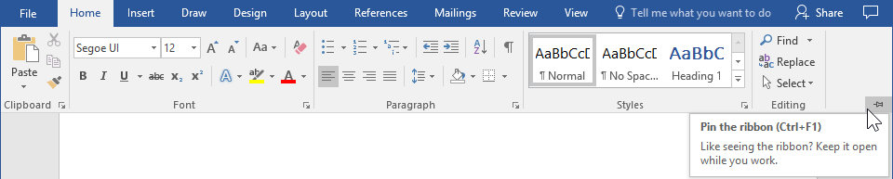

**To access menus from the keyboard in any Windows application, press the Alt key.**

The menu items will light up with shortcut keys for applications with a ribbon interface like the Office products (Word, Excel, PowerPoint, …). At any time, you can hover the mouse over a ribbon icon and it will show a tool tip explanation and a reminder of the keyboard shortcut (see below). So, the mouse is good for something.

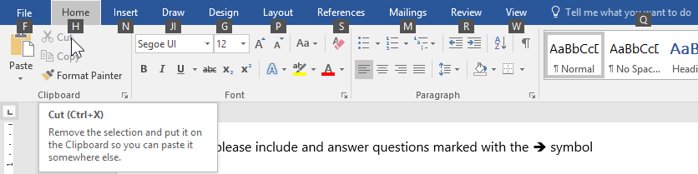

In other applications with a traditional menu, like Visual Studio, after pressing the Alt key, you will see characters underlined which are the shortcut keys. E.g.



Once the menu is activated by the Alt key, you can release the Alt key. The first menu item (usually File) will be highlighted to indicate the menu is active. Although you can use the 🡨 🡪 🡫 arrow keys to select or open a menu, keying an underlined letter is more direct.



Keying an ‘F’ will show the File’s menu.   
*Upper or lower case can be used; this is known as “case independent”.*Key an ‘N’ for the New sub-menu. Then a ‘P’ for the new Project dialog.  
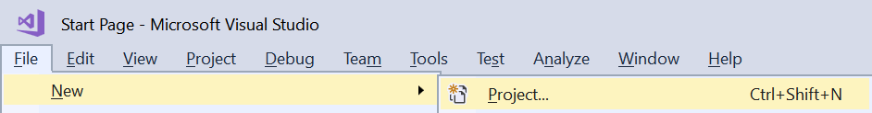

Any time you see an underlined letter in a dialog, you can press and hold Alt + the underlined letter to move the focus there. E.g. Alt+*Letter*  in the screen shot below selects the characters in the Name text box allowing you to change it. The TAB key will also move the focus between fields.

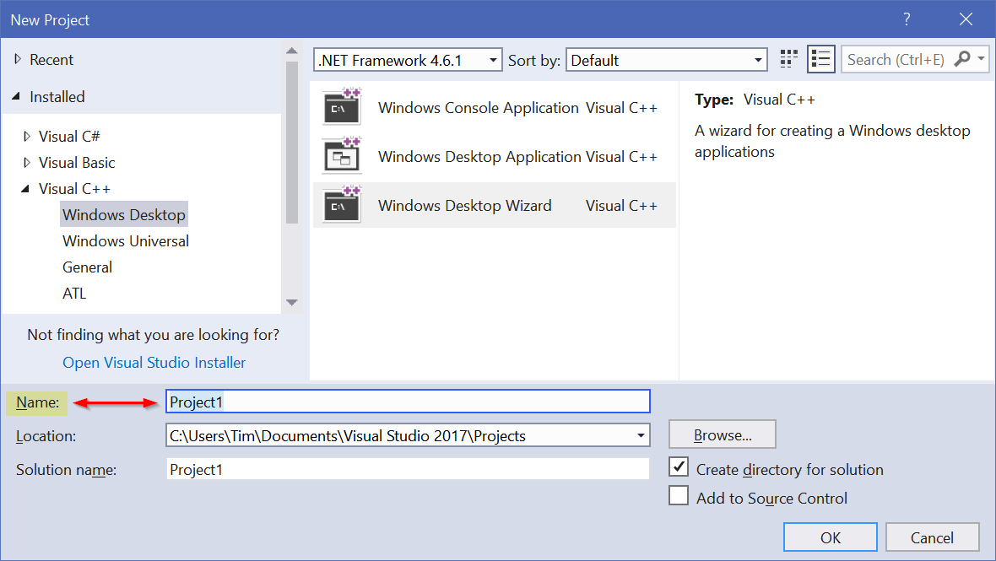

Navigation and selection:

|  |  |  |  |
| --- | --- | --- | --- |
|  | Moves cursor | Ctrl + moves to | Shift + |
| Arrow up/down | One line | Next paragraph | Selects |
| Arrow left/right | One char | Next word | Selects |
| Home | Start of line | Start of document | Selects |
| End | End of line | End of document | Selects |
| Page Up | One page up | Top of previous page | Selects |
| Page Down | One page down | Top of next page | Selects |

Modification:

Ctrl+X Cut a selection to the Clipboard

Ctrl+C Copy a selection to the Clipboard

Ctrl+V Paste a selection from the Clipboard

Ctrl+Z Undo a change

Ctrl+Y Redo a change or Undo the Undo

Ctrl+F Find text in a document

Ctrl+H Find and Replace text in a document

Text Enhancement:

Ctrl+B Make selected text **bold**

Ctrl+U Make selected text underlined

Ctrl+I Make selected text *italic*

<http://www.digitaltrends.com/computing/cut-copy-paste-beginners-guide/>

<http://www.howtogeek.com/115664/42-text-editing-keyboard-shortcuts-that-work-almost-everywhere/>

<https://support.microsoft.com/en-ca/help/12445/windows-keyboard-shortcuts>

<http://www.hongkiat.com/blog/100-keyboard-shortcuts-windows/>

For keyboard shortcuts, refer to the notes above and the handouts.

**For the rest of this activity, put your mouse out of reach.**Copy all the lines below from **Begin-Practice** to **End-Practice** *inclusive*  
to your activity answer document – all without using the mouse:

*Select paragraphs with* Ctrl+Shift+🡫*,* Ctrl+C *to copy,*Alt+Tab *changes to answer document,* Ctrl+V *to paste.*

Then, complete the following 🡺 actions…and *no mousing*.

*🡺* **Begin-Practice**

🡺 Sequence the words of an A – Z typing exercise from alphabetical order into  
a grammatically correct sentence. *Select, cut, paste. Home, End, Ctrl+🡨🡪*   
**a brown dog. fox jumps lazy over quick The**

🡺 Go to the end of this line using a single keystroke and type your name 🡺   
 What was the keystroke that sent the cursor to the end of the line? 🡺

🡺 Cut this entire line and paste it to appear immediately above **End-Practice**.

🡺 Convert this line to **bold** using the minimum number of keystrokes.   
What were the keystrokes to position, select, and perform the text enhancement?

🡺 Underline the word underline where it appears in this sentence.

🡺 Make all instances of the word "italics" on this line into italics…and more italics.

🡺 Move this paragraph *(Alt+Shift+Up)* to appear immediately below "**Begin-Practice"**. As long as the cursor is somewhere within this paragraph, the whole paragraph will be auto selected and moved with the Alt+Shift+Up/Down keyboard shortcut.

🡺 Move the following three paragraphs so they are in ascending order   
and change their font type, style, and size to be the same as this line's:

3. Real Programmers don't comment their code.   
If it was hard to write, it should be hard to understand.

2. Real Programmers don't write specs -- users should consider themselves lucky to get any programs at all, and take what they get.

1. Real Programmers use C because it's the easiest language to spell.

*🡺* **End-Practice**

🡺 complete the following Visual Studio demo and see the 🡺 at the end

# Visual Studio customization and IntelliSense demo

Reference: <https://docs.microsoft.com/en-ca/visualstudio/ide/default-keyboard-shortcuts-in-visual-studio> -- Microsoft’s documentation on Default Keyboard Shortcuts in Visual Studio is also available from the Help menu (Alt+H K).

Start Visual Studio and Customize the editor.

**#include <stdio.h> // Input/Output**

SICT uses this style of braces **int main(void)**

**{**

**printf("Hello, World!\n");**

**}**

#include <stdio.h> // Input/Ouput

instead of this int main(void) {   
 printf("Hello, World!\n");

}

Override the default VS option to control the formatting behaviour…

**Alt** + **T** for the Tools menu. **O** for Options

**Text Editor** **/ All Languages / General**

Text Editor,– default to Word wrapping in all cases.  
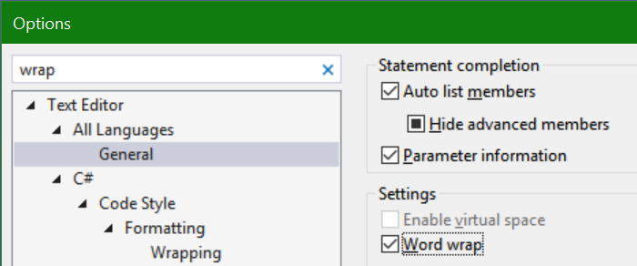

**Text Editor** / **C/C++** / **Formatting** / **New Lines** /

Use TAB to move between sections of the dialogue. Use Up/Down arrows to move within a section of the dialogue. Use the spacebar to select items.

"Position of open braces" –> select **Move to a new line** in all cases  
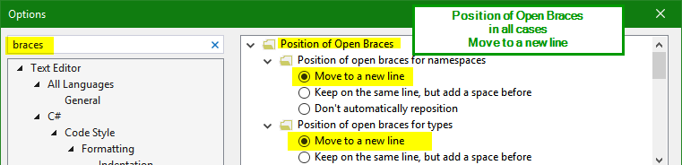

**Text Editor** / **C/C++** / **Formatting** / **Wrapping** /

– Always apply New Lines Setting for blocks   
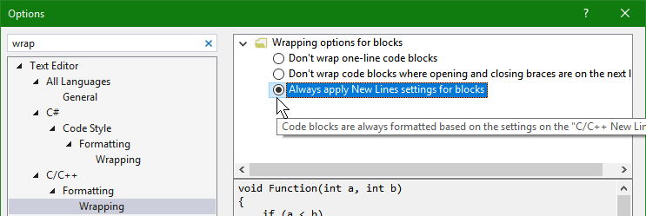

N.B. If you set up the editor to be 8 pt purple text on a black background, it may look cool but don’t ask anyone over the age of 25 to look at your code.   
A simple way to make it easy for others to see your code is to zoom in. Use Ctrl with the mouse wheel (up to zoom in, down to zoom out). There's a zoom control in the bottom-left of the code editor.

**Create a new Visual Studio Project and add a new helloWorld2.C source file.  
Select the poorly formatted C code below and paste it into the VS editor.**

/* Thanks to Brian Kernighan, 'Hello World' is the traditional first C program. It became legendary with the publication of "The C Programming Language" by Kernighan and Ritchie (1978). Now, Hello World is the canonical test of any programming language. */

#include <stdio.h> // C language module providing Input/Output facilities

// main() is always called to start a C program

int main(void){ printf("Hello, World!\n"); // output greeting

printf("This is yourNameHere.\n"); // output your name

return 0;}

* It’s similar to last week’s code but with messed up tab indenting and braces style.  
  When you copy and paste the above code into Visual Studio, magic happens: the code is automatically formatted.
* **Ctrl+Z** to Undo the auto formatting so it looks like the messed up version above.
* **Ctrl+KD**, (hold Ctrl down, press K then D). This will reformat your C code to industry standards. Additional line spacing for readability is recommended.
* **Ctrl+S** – Save early, save often.

Position the cursor anywhere inside the helloWorld2.c editing window.

* Press Ctrl+A
* Press Delete
* Oops. Always be careful about selecting all text before doing something.
* Press Ctrl+Z ( UNDO – the key sequence we are all thankful for)

Special Copy, Cut, Duplicate shortcuts in Visual Studio.

***Without*** selecting a line or text,   
Ctrl+D – Duplicates the line of code the cursor is on

Ctrl+C – Copies the line of code the cursor is on

Ctrl+X – Cuts the line of code the cursor is on

**IntelliSense and code completion:**

* IntelliSense assists programming by offering automatic code and syntax completion.
* IntelliSense is sensitive to the source file extension, e.g. _____.c for C language source files. Only items relevant to that source file language are displayed.
* IntelliSense is activated when you begin to type a command, function, or variable name, e.g. "pr" to print. A list appears with items matching the characters typed.
* Pressing TAB selects the default item and completes your partially typed code. Use Up/Down to select a different item in the IntelliSense list and press TAB or Enter to insert that item.
* Ctrl + Spacebar turns on IntelliSense before you start typing or when it is staying out of your way
* Key ( for a left parenthesis, and the right hand ) is automatically inserted with the cursor positioned between them; for a function like printf, the comments and parameters are shown.
* * Key " to open a quoted string of characters and IntelliSense automatically inserts a matching double-quote "; the cursor is positioned inside the quotes ready for the entry of a text string. This works for any matched pair of punctuation marks: ( )   { }   [ ]   " "   ' '   /* */

Watch the video demonstration by double clicking the box below  


Replace yourNameHere with your name.

Add a new line of code using code completion features.   
Each 🡸 below is a keystroke-by-keystroke step to build a single line of code.

/* Hello World program. Computer Principles for Programmers Week 2. IntelliSense exercise. */

int main(void)   
{

printf("Hello World, ");

printf("This is yourName.\n"); 🡸 position cursor at end of this line, **press Enter** to start a new line

🡸 key “**pr**”, IntelliSense code completion dialog opens, **press TAB** − “printf” appears

*printf*🡸 key **(** *left parenthesis*. Then key **“** *double quote.* Watch what happens.

printf("more console output"); 🡸 resulting print command with text

return 0;  
}

🡺 Copy your new helloWorld2.c source code from Visual Studio (Ctrl+A, Ctrl+C) and paste in the box below using the Paste Option to either Merge Formatting (M) or Keep Text Only (T)

* Backup your entire Visual Studio project folder to a USB drive or zip it into an archive and save the zip file in OneDrive or the Blackboard Content System. E.g.  
  C:\Users*yourUserName*\Documents\Visual Studio 2017\Projects\CP4P_w1  
  see screen shot below.

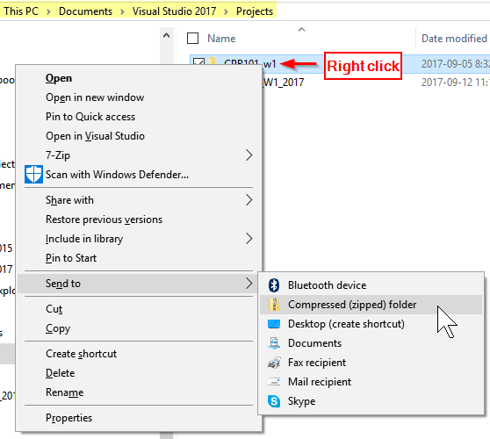

Or, if 7-Zip is installed, use it to "Add to "*YourProject*.zip"

**Tip**: copy this arrow 🡺 character, Ctrl-F to find, paste the arrow and search both this activity document and your answer document to ensure you have completed all the steps before submitting.

Please ensure you have copied your helloWorld2.c source code to your Word .docx answer file. There is no need to upload the source code file or the Visual Studio project.

If you want to keep all your C programs in a single Visual Studio project, know that only one C source file can have a **main**(). Incorporate the week number into your C source file name along with -Lab or -Home. When starting a new source file, rename **main**() in the previous source to be the same as the source file name.

[Easter Egg](https://en.wikipedia.org/wiki/Easter_egg_(media)) (answering is optional)

🡺 Their are three misteaks in this sentence. 🡸 Is that sentence True or False…and why?